London Community Resilience Toolkit: Template Workbook



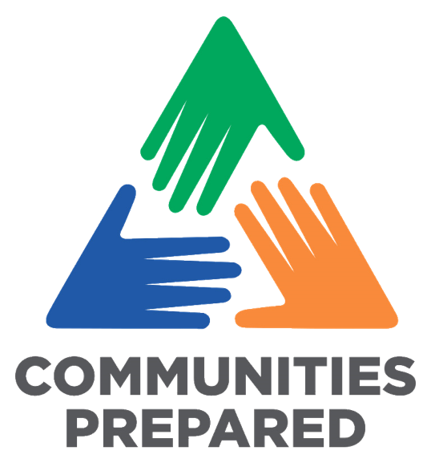
https://www.communitiesprepared.org.uk/london-community-resilience-toolkit/

Page 23: Checklist for Getting Started
Page 26: Community Emergency Plan Details
Think about how you kick start the session to grab people’s attention.
You might want to set the scene with a local example of an emergency or scenario (use a real example if you can).
What would happen:
- If there was a flood on the high street or along a main road?
- If there was a fire in the park or in an important building?
- If there was a power outage or water outage?
Decide how you want to develop your community map.
You know your community best – how do they like to engage? Make sure you have the necessary tools and resources.
- Creative activities e.g. drawing diagrams and using post-it notes
- Practical action e.g. talking a walk around the local area.
- Desk-based research and speaking with others.
- Facilitated conversations or workshops with your groups.
- If meeting virtually, research and trial the best software before you meet.
How are you coming together?
Are you using an existing meeting or event? Or a specific time and location, or are you meeting virtually?
Allocate enough time for collaboration and discussion.
This isn’t about getting to the solution quickly, it’s about developing and creating a clear map of your community, in a way that works for you, that also helps to build new relationships.
Seek to understand what mapping already exists.
Often others have completed a mapping exercise before, which you could use and potentially build on to save a lot of time.
Decide if you are approaching this collectively or individually.
Collectively is ideal so you can tap into knowledge and wisdom outside of your group or organisation.
Name of your community:
Key factors to consider in your community:
Start and completion dates of your plan:
Lead designated person and their contact details:

Page 31: Community Partners Table
What role will they play, or what resources do they have?
Organisation / Partner Name | Description of what they do | Contact Information | Role or Resources in an emergency
Example: Knowheresville Community Transport | Example: An organisation that support older people primarily with transport. | Example: Jayne Doe, 14 Knowhere Lane, Knowheresville, KN1 4TT. 0202 222 4444 | Example: Can provide a minibus, also has contact with other community transport groups
Page 33: Community Risks and Impacts Table
List below the risks and impacts that you want to consider and include as part of your Community Emergency Plan. Remember to include the impacts that you might not necessarily experience yourself, considering how people from different backgrounds and with different abilities may be affected.
Risks | Impacts | Actions
Example: Heatwave | Example: Dehydration and Fatigue | Example: set up a cool space where water is available and people can rest from the heat.
Page 35: Key Skills for an Emergency

Key Skills for an Emergency
List below the people and skills you have in your organisation or network to help respond to an emergency or major challenge in your community.
Key Skill in an emergency | People who have this skill | Contact details | Availability
Example: First Aid | Example: Jayne Doe | Example: 0202 333 5555 | Example: on weekdays

Gaps Identified | Actions to address gaps: | Responsible | Completed
1)
2)
3)
4)
5)
6)
7)
8)
9)
10)
11)
12)
13)
14)
15)
16)
17)
Page 37: Skills and Resources Gaps
Emergency Contacts
Fill out the below table of key emergency contacts you need to activate your plan.
Organisation | Contact Details | Role and Responsibility
Example: Knowheresville Local Council | Example: 0202 111 2222 www.knowheresville.gov.uk/emergencies | Example: The local council will coordinate local response to an emergency, including supporting residents.
Page 41: Emergency Contacts
Page 43: Practice and Exercise Log

Practice and Exercise Log
Use the table below to capture the learnings from tests and practices of your Community Emergency Plan
Practice or exercise date | What went well? | What needs improving? | Key actions from learning
Example: 1st December 2024 | Example: Communication relevant people worked and happened quickly | Example: More understanding needed of what to do / not do in an emergency. | Example: Increase knowledge and awareness of hazards and the actions to take.
Page 62: Your Reflection

How did you approach the toolkit and the tasks?
What was something that you learnt?
What was something that you enjoyed?
If you were going to start the process again, what would you do differently?
When are you next going to review the toolkit and update your Community Emergency Plan?
Page 63: Activities and Actions you are taking forward

Action/ Activity
Action/ Activity
Action/ Activity
Action/ Activity
Action/ Activity
Action/ Activity
Action/ Activity

